L-1K1W1007851A project enclosure assembly instructions 20260720
1.The enclosure is divided into upper and lower parts. When installing the lower shell into the PCBA, first align the USB-C and then put it in. Make sure the microphone opening on the upper cover is aligned with the PCBA opening. After installation, drive in four M3X10 hexagon socket head screws.
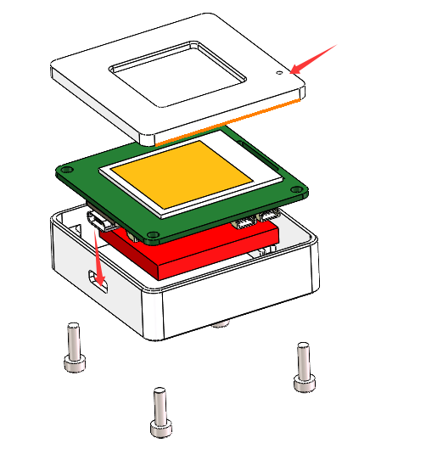
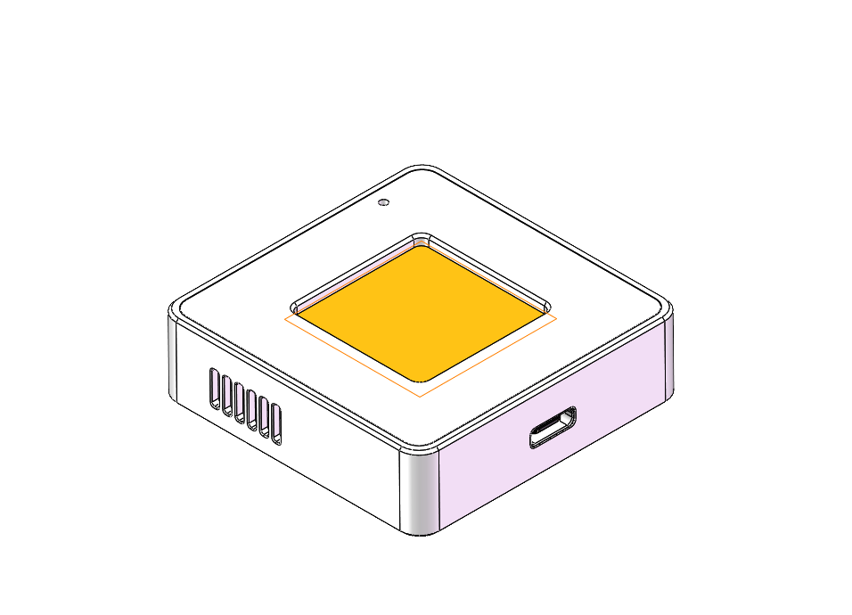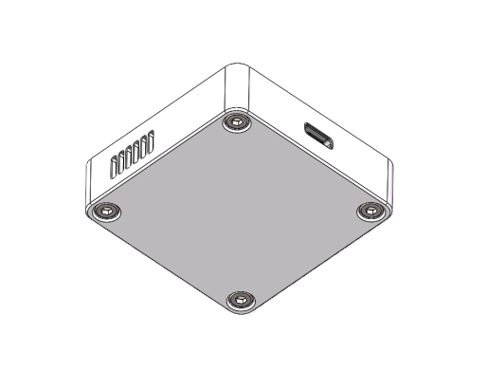
2. Regarding the battery, you can use double-sided tape to fix it on the casing, or you can fix it on the PCBA.

